DS Assignment 1 24-8-2016
1A. Using typedef give a structure definition to represent a student structure named STUDENT whose fields are student Name, five Assignment scores, and two Test scores and one EndSem Mark, and one TotalMark . (1)
1B. Write a program using Array of structure to read details into student Name, five Assignment scores, and two Test scores and one EndSem Mark, and one TotalMark for students of size N. As per MIT internal assessment scheme, compute the total marks out of 100 by adding 20 Marks for assignment, 30 Marks for test scores and 50 Marks for EndSem and store in the structure field TotalMark. Use separate functions to read, display and compute total marks. Use arrays for all fields except EndSem Mark and TotalMark field. (3)
2A. Use a structure pointer and typedef to repeat the structure definition of Q1A. (1)
2B. Using structure pointer to an array of structure rewrite the above program. (3)

3A. Write a function int *odd( int N) which generates first 10 odd numbers and stores in an array and returns the base address of the array. Use main () to print the odd numbers generated by odd(int ) function. (3)
3B. Let int a[10][10] be the 2D array and its base address is assigned to a pointer variable p. Write a “C” code to read and display M X N elements using pointer variable p. (1)

4A. Write a function to free the memory allocated to a ragged array. The function must have the following prototype.
int memRelease(int **);
Function must return 1 on success -1 on failure.
4B. Write a function which takes a ragged array as input and copies the contents into a dynamically allocated 1-D array. The pictorial representation of ragged array is shown below. The table pointer points to the first pointer in an array of pointers. Each array pointer points to a second array of integers, the first element of which is the number of elements in the list. [Assume memory is allocated and elements have been stored in the ragged array]. Function must have the following prototype.
int * copyto1D(int **table);
where the function returns a pointer to the dynamically allocated 1-D array
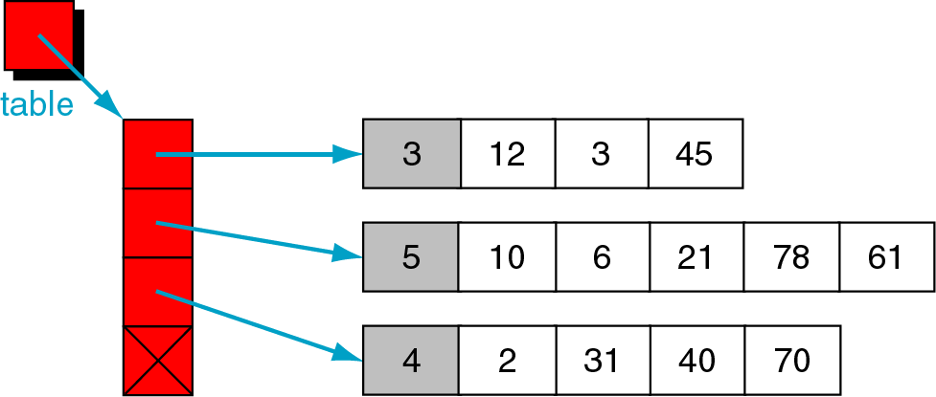

5A. i) In what ways can enumeration variables be processed? What restrictions apply to the
processing of enumeration variables?
ii) Explain the purpose of the following program outline.
int score = 0;
enum compass {north, south, east, west} move;
switch (move) {
case north:
score += 10;
break;
case south:
score += 20;
break;
case east:
score += 30;
break;
case west:
score += 40;
break;
default :
printf(“ERROR - Please try again\n") ;
} (2)
5B. What is the purpose of the typedef feature? How is this feature used in conjuction with complex structures? Explain with an example? (2)

